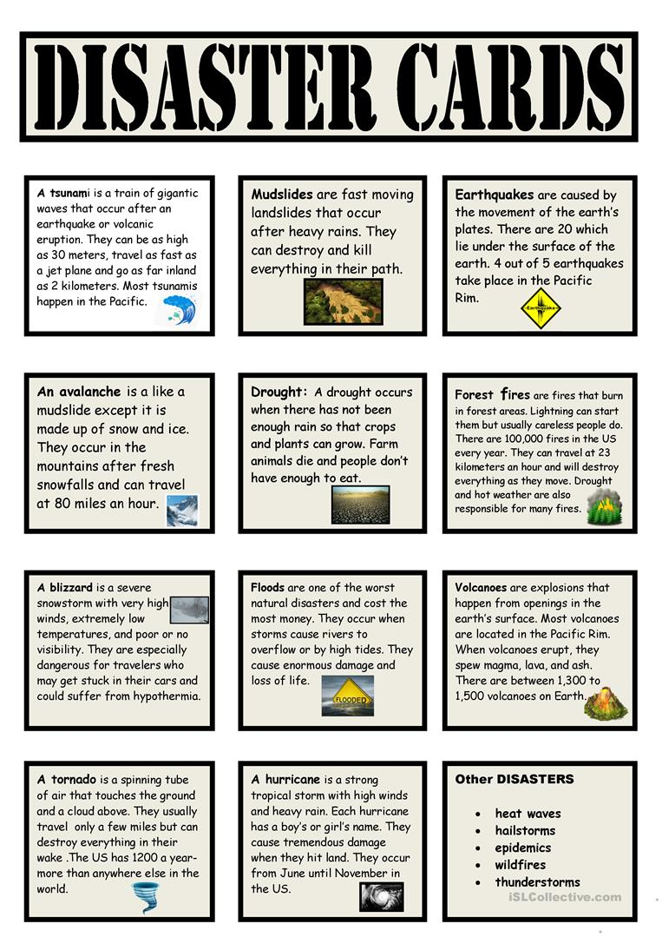

Read the description of the natural disasters. Can you match the disaster to the pictures and photos on the other sheet?

Are there any photos that could fit more than 1 disaster? Why?