The Witching Hour
Sophie couldn't sleep.
A brilliant moonbeam was slanting through a gap in the curtains. It was shining right on to her pillow.
The other children in the dormitory had been asleep for hours.
Sophie closed her eyes and lay quite still. She tried very hard to doze off.
It was no good. The moonbeam was like a silver blade slicing through the room on to her face.
The house was absolutely silent. No voices came up from downstairs. There were no footsteps on the floor above either.
The window behind the curtain was wide open, but nobody was walking on the pavement outside. No cars went by on the street. Not the tiniest sound could be heard anywhere. Sophie had never known such a silence.
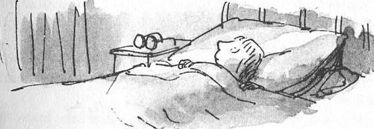
Perhaps, she told herself, this was what they called the witching hour.
The witching hour, somebody had once whispered to her, was a special moment in the middle of the night when every child and every grown-up was in a deep, deep sleep, and all the dark things came out from hiding and had the world to themselves.
The moonbeam was brighter than ever on Sophie's pillow. She decided to get out of bed and close the gap in the curtains.
You got punished if you were caught out of bed after lights-out. Even if you said you had to go to the lavatory, that was not accepted as an excuse and they punished you just the same. But there was no one about now, Sophie was sure of that.
She reached out for her glasses that lay on the chair beside her bed. They had steel rims and very thick lenses, and she could hardly see a thing without them. She put them on, then she slipped out of bed and tip-toed over to the window.
When she reached the curtains, Sophie hesitated. She longed to duck underneath them and lean out of the window to see what the world looked like now that the witching hour was at hand.
She listened again. Everywhere it was deathly still.
The longing to look out became so strong she couldn't resist it. Quickly, she ducked under the curtains and leaned out of the window.
In the silvery moonlight, the village street she knew so well seemed completely different. The houses looked bent and crooked, like houses in a fairy tale. Everything was pale and ghostly and milky-white.
Across the road, she could see Mrs Rance's shop, where you bought buttons and wool and bits of elastic. It didn't look real. There was something dim and misty about that too.
Sophie allowed her eye to travel further and further down the street.
Suddenly she froze. There was something coming up the street on the opposite side.
It was something black ...
Something tall and black ...
Something very tall and very black and very thin.
Sophie opened her mouth to scream, but no sound came out…

